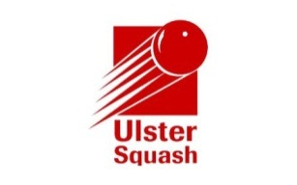

Application for Individual Membership

Completing this form means you agree to subscribe to the Ulster Squash emailing list to be kept up to date with news and events.

Title: | Mr / Mrs / Miss / Ms / Other (Please circle as appropriate)
Name:
Address:
Post code:
E-mail address: |  |  | Date of birth:
Telephone (Home): |  | (Mobile):
Club(s):

I hereby apply for the following category of individual membership:

Category | Note | Annual Subscription | Tick relevant box
Associate |  | £15
Junior | Under 19 at time of application | £0
Senior |  | £25

Payment should be made through the website and completed applications should be returned to;

Membership Applications
Ulster Squash
Lisburn Racquets Club
36 Belfast Road, Lisburn
BT27 4AS

If successful in my application, I agree to abide by the constitution and rules, byelaws and other regulations of Ulster Squash.
Signed: |  | Date:

